**Scraping Data from Spotify Playlist**

**1.Introduction**

In the dynamic landscape of music streaming, understanding the composition of playlists can offer valuable insights for music enthusiasts, researchers, and industry professionals alike. Spotify, being a prominent player in this domain, provides a platform rich with curated playlists spanning various genres and moods. The motivation behind this Python script is to empower users to harness Spotify's vast musical database by scraping data from playlists. this script serves as a key to unlock the details hidden within Spotify playlists. By extracting information such as playlist name, creator details, follower count, and individual song details like added dates, track names, artists, and album names, users can delve into the intricacies of playlists. This data can be further analysed, visualized, or integrated into larger projects, offering a deeper understanding of musical preferences, trends, and patterns. This blog will guide you through the process of setting up your environment, understanding the code, and running the script step by step.

**2.Setting Up Spotify API Access**

Unlocking Spotify's musical wonders is as easy as securing two special keys: the client ID and client secret ID. To get these two keys from Spotify Developer account.

Step into the world of musical magic by creating your Spotify Developer Account. It's a breeze – just like jamming to your favourite tunes! 🎶

Visit the Stage: Head over to the [Spotify Developer Dashboard](https://developer.spotify.com/) – your backstage entrance to the music scene.

If you already Created please login otherwise create an account, it's just as easy as creating your regular Spotify account.

Hit 'Create an App': It's like naming your band. Give your app a cool name and tell us what it's about. Get creative!

Grab Your VIP Passes: Your app now has a VIP pass – the client ID and client secret. They're like your backstage access codes.

Now, let the musical exploration begin!

**3.Installing Required Libraries**

Installing Libraries:

* + - Open your terminal or command prompt.
    - Type **pip install spotipy** and hit enter.
    - Get ready to groove!

**4. Code Explanation**

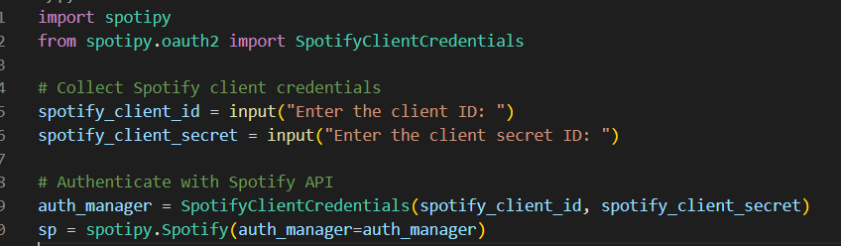**Authenticating with Spotify API:**

Import Libraries: The code imports necessary libraries from Spotipy for interacting with the Spotify API.

User Input: Collects user input for Spotify client ID and client secret.

Authentication: Utilizes Spotipy's SpotifyClientCredentials to authenticate with the Spotify API, using the provided client credentials. The authenticated Spotify instance is stored in the variable sp.

**Gathering Playlist Information:**

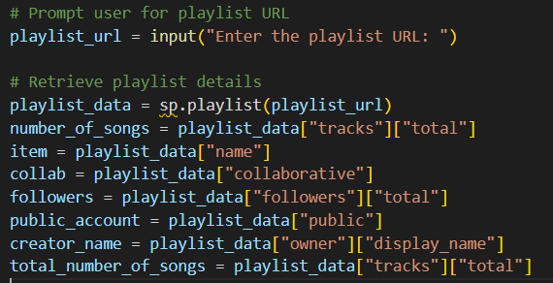

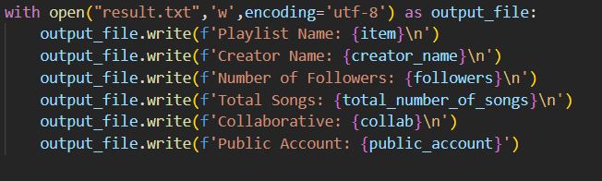Writing Playlist Information to Text File:

User Input: Prompts the user to input the Spotify playlist URL.

Retrieve Playlist Details: Utilizes the authenticated Spotify instance (sp) to retrieve various details about the playlist, such as name, collaboration status, number of followers, and more. These details are stored in variables for later use.

**Writing Playlist Information to Text File:**



Write to Text File: Opens a text file named "result.txt" in write mode and writes essential playlist details to it. This includes the playlist name, creator name, number of followers, total songs, collaboration status, and public account status.

**Scraping Song Data:**

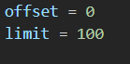

Initialize Variables: Sets up variables for later use in the loop that iterates through the playlist's tracks. offset and limit are used for pagination, ensuring all tracks are retrieved.

**Writing Song Data to CSV File:**

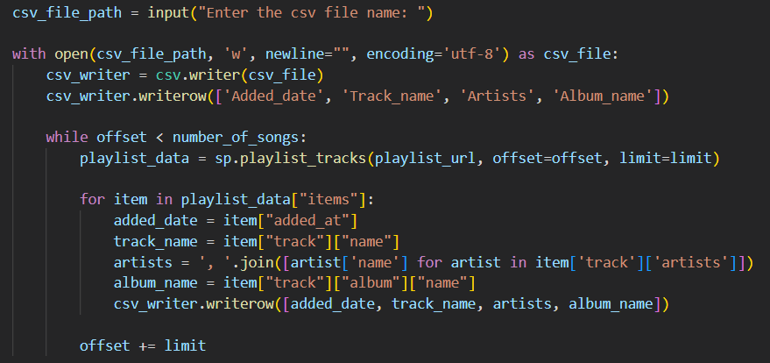

Displaying Results:

User Input: Prompts the user to provide the desired name for the CSV file.

Write to CSV: Opens a CSV file in write mode and writes the scraped song data (added date, track name, artists, album name) to it. It uses a loop to handle pagination and iterates through the playlist's tracks.

**Displaying Results:**

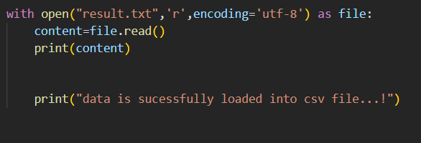

Read and Display: Opens and reads the content from the "result.txt" text file and prints it to the console.

Success Message: Prints a success message to indicate that the data has been successfully loaded into the CSV file.

Conclusion:

embarked on a musical expedition, extracting secrets from playlists and dancing with the Spotify API. Your Python script is now a wizard, waving its code wand to conjure insights from the vast realm of playlists.

Remember, in this symphony of code, you're the conductor, orchestrating a data-driven crescendo. So, whether you're uncovering playlist gems or exploring trends, let the beats guide you, and may your data dance with joy!

As you revel in the results, pat yourself on the back – you've graduated from script apprentice to playlist maestro. Now, go forth, analyse those rhythms, and may your insights be as sweet as your favourite melody!

**GitHub Link:**

**<https://github.com/ajithkumarece046/Spotify-Data-Scraper>**